Fall 2015 COMP 3511 Homework Assignment #2
Handout Date: Oct 5, 2015 Due Date: Oct 19, 2015
Name: ___________________ ID: ___________________
E-Mail: _______________ Section: ________________

Please read the following instructions carefully before answering the questions:
- You should finish the homework assignment individually.
- There are a total of 4 questions.
- When you write your answers, please try to be precise and concise.
- Fill in your name, student ID, email at the top of each page.
- Please fill in your answers in the space provided, or you can type your answers in the Microsoft Word file.

- Homework Collection: the hardcopy is required and the homework is collected in collection box #16 (for L1) and collection box #17 (for L2). The collection boxes are located outside Room 4210, near Lift 21 (there are labels on the boxes).

- (20 points) Multiple choices
  - A ____ provides an API for creating and managing threads.
A) set of system calls
B) multicore system
C) thread library
D) multithreading model

  - Which of the following would be an acceptable signal handling scheme for a multithreaded program?
A) Deliver the signal to the thread to which the signal applies.
B) Deliver the signal to every thread in the process.
C) Deliver the signal to only certain threads in the process.
D) All of the above

  - The ____ multithreading model multiplexes many user-level threads to a smaller or equal number of kernel threads.
A) many-to-one model
B) one-to-one model
C) many-to-many model
D) many-to-some model

  - ________ involves distributing tasks across multiple computing cores.
A) Concurrency
B) Task parallelism
C) Data parallelism
D) Parallelism

  - According to Amdahl's Law, what is the speedup gain for an application that is 40% parallel and we run it on a machine with 4 processing cores?
A) 0.7
B) 1.82
C) 0.55
D) 1.43

  - ____ is the number of processes that are completed per time unit.
A) CPU utilization
B) Response time
C) Turnaround time
D) Throughput

  - The ____ scheduling algorithm is designed especially for time-sharing systems.
A) SJF
B) FCFS
C) RR
D) Multilevel queue

  - Which of the following is true of multilevel queue scheduling
A) Processes can move between queues.
B) Each queue has its own scheduling algorithm.
C) A queue cannot have absolute priority over lower-priority queues.
D) It is the most general CPU-scheduling algorithm.

  - ______ allows a thread to run on only one processor.
A) Processor affinity
B) Processor set
C) NUMA
D) Load balancing

  - A significant problem with priority scheduling algorithms is _____.
A) complexity
B) starvation
C) determining the length of the next CPU burst
D) determining the length of the time quantum

- [15 points] Threads
  - (5 points) Please briefly explain why a (busy) database server should not run as a single-threaded process.

  - (5 points) Please briefly describe the difference between the fork() and clone() Linux system calls

  - (5 points) What is the advantage of deferred cancellation over asynchronous cancellation?

- [25 points] Please answer the following questions in a few sentences
  - (5 points) What is processor affinity? What are hard affinity and soft affinity?

  - (10 points) Consider a system running ten I/O-bound tasks and one CPU-bound task. Assume that the I/O-bound tasks issue an I/O operation once for every millisecond of CPU computing and that each I/O operation takes 10 milliseconds to complete. Also assume that the context-switching overhead is 0.1 millisecond and that all processes are long-running tasks. Describe is the CPU utilization for a round-robin scheduler when:
a) The time quantum is 1 millisecond
b) The time quantum is 10 milliseconds

  - (5 points) Consider the scheduling algorithms, FCFS, SJF, RR, SRTF and priority scheduling, which can result in starvation and why?

  - (5 points) Please describe the usage of process-contention scope and system-contention scope.

- [40 points] CPU Scheduling

  - (20 points) Given the arrival time and CPU-burst of 5 processes shown in the following diagram:
Process | Arrival Time (ms) | Burst Time (ms)
P1 | 0 | 8
P2 | 2 | 2
P3 | 6 | 15
P4 | 12 | 4
P5 | 19 | 13
Suppose the OS uses a 3-level feedback queue to schedule the above 5 processes. Round-Robin scheduling strategy is used for the queue with the highest priority and the queue with the second highest priority, but the time quantum used in these two queues is different. First-come-first serve scheduling strategy is used for the queue with the lowest priority. The scheduling is preemptive.

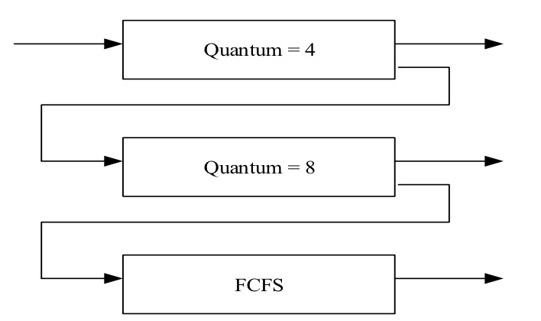

a) (10 points) Construct a Gantt chart depicting the scheduling for the set of processes specified in the above diagram using this 3-level feedback queue.

b) (10 points) Calculate the average waiting time for the schedule constructed in a).

  - (20 points) Consider the following set of processes, with the length of the CPU burst time given in milliseconds:

Process | Arrival Time(ms) | Burst Time(ms)
P1 | 0 | 30
P2 | 19 | 15
P3 | 42 | 24
P4 | 27 | 10
P5 | 3 | 59

- (10 points) Draw three Gantt charts that illustrate the execution of these processes using the scheduling algorithms listed below:
- Shortest-Job-First
- Shortest-Remaining-Time-First (Preemptive Shortest-Job-First)
- Round-Roubin (quantum = 8)

- (5 points) What is the turnaround time of each process for each of the scheduling algorithms in part a?

Turnaround time | P1 | P2 | P3 | P4 | P5
SJF
SRJF
RR

- (5 points) What is the waiting time of each process for each of these scheduling algorithms in part a?

Waiting time | P1 | P2 | P3 | P4 | P5
SJF
SRJF
RR

